CREATING STAND ALONE AGENT AND CONFIGURING CLOUD NODE IN JENKINS FOR OCP
CMSUPPORT-137237
OCP Kubernetes Cluster Integration with Jenkins
Prerequisites to be collected from User:
Openshift service account name = svc-comm-orch-cicd-jenkins

Openshift namespace = output-solutions-communiation-apis

Openeshift environment = Dev ([1]https://sdlocp.fisdev.local/)

BB project name/URL = [2]https://bitbucket.fis.dev/projects/COMMORCH

Jenkins project name/URL = [3]https://jenkins.fis.dev/bnk/job/COMMORCH/job/COMMORCH/job/

Note: Get access for the Openshift Namesapce from the user side.
Note: Service Account Token should be provided by the user which will be used as “Secret Text” while creating credentials in Jenkins.

For this development team need to provide details like OpenShift Namespace or Linux/Window VM details.
How to integrate OpenShift Namesapce as a Cloud Node?

- CREATING SERVICE ACCOUNT IN THE OCP NAMESPACE
- cmops-cicd-dev is the namespace example taken here.
- https://sdlocp.fisdev.local/console/project/cmops-cicd-dev/
- Service account creation: Method 1 (CLI)
- Login to OCP. One must request the user to provide Admin access to the OCP project we need to configure.
- Once logged into the OCP project, go to User Profile on Top Right corner and Copy Login Command

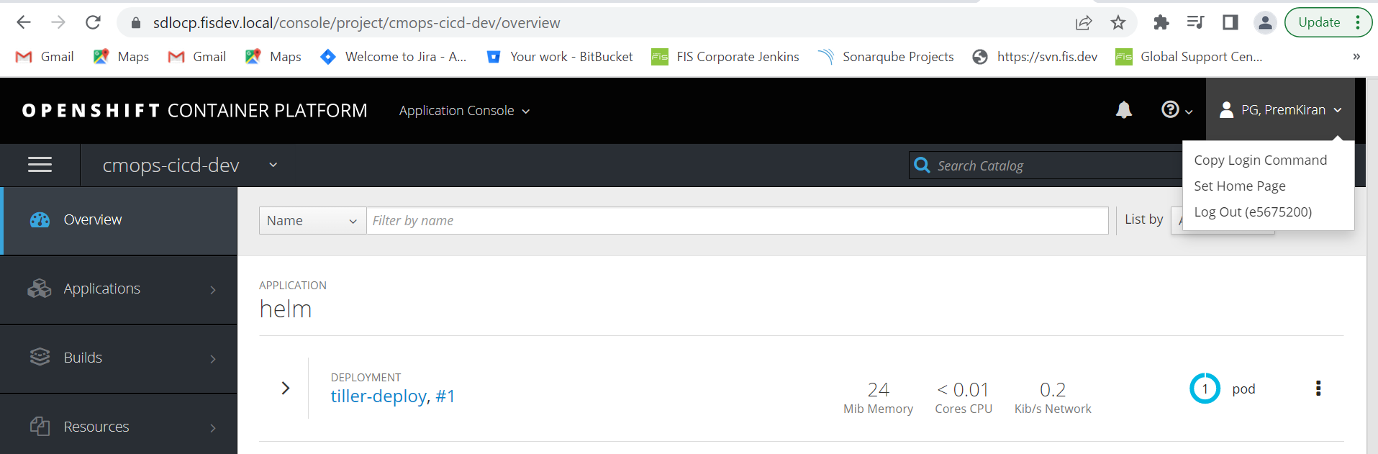

- Once copied, open cmd and paste the command.
- If you get the below error, you need to configure oc client in your local machine first.
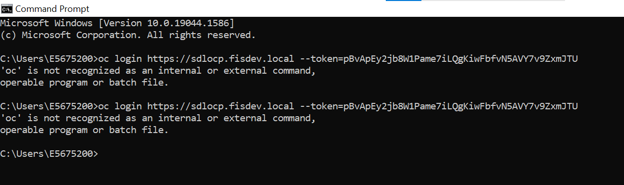

- Download the file from below path.
https://fisglobal-my.sharepoint.com/:u:/p/harinath_sangala/EYsxd32RmntDujkBFriGgTIBIWdZVXUww_GNuw4J8vrT5Q

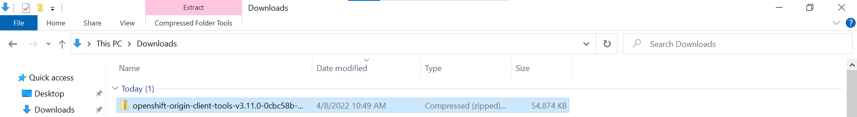

- Create a folder “softwares” in C Drive and copy the zip file -> extract “oc” within the “softwares”
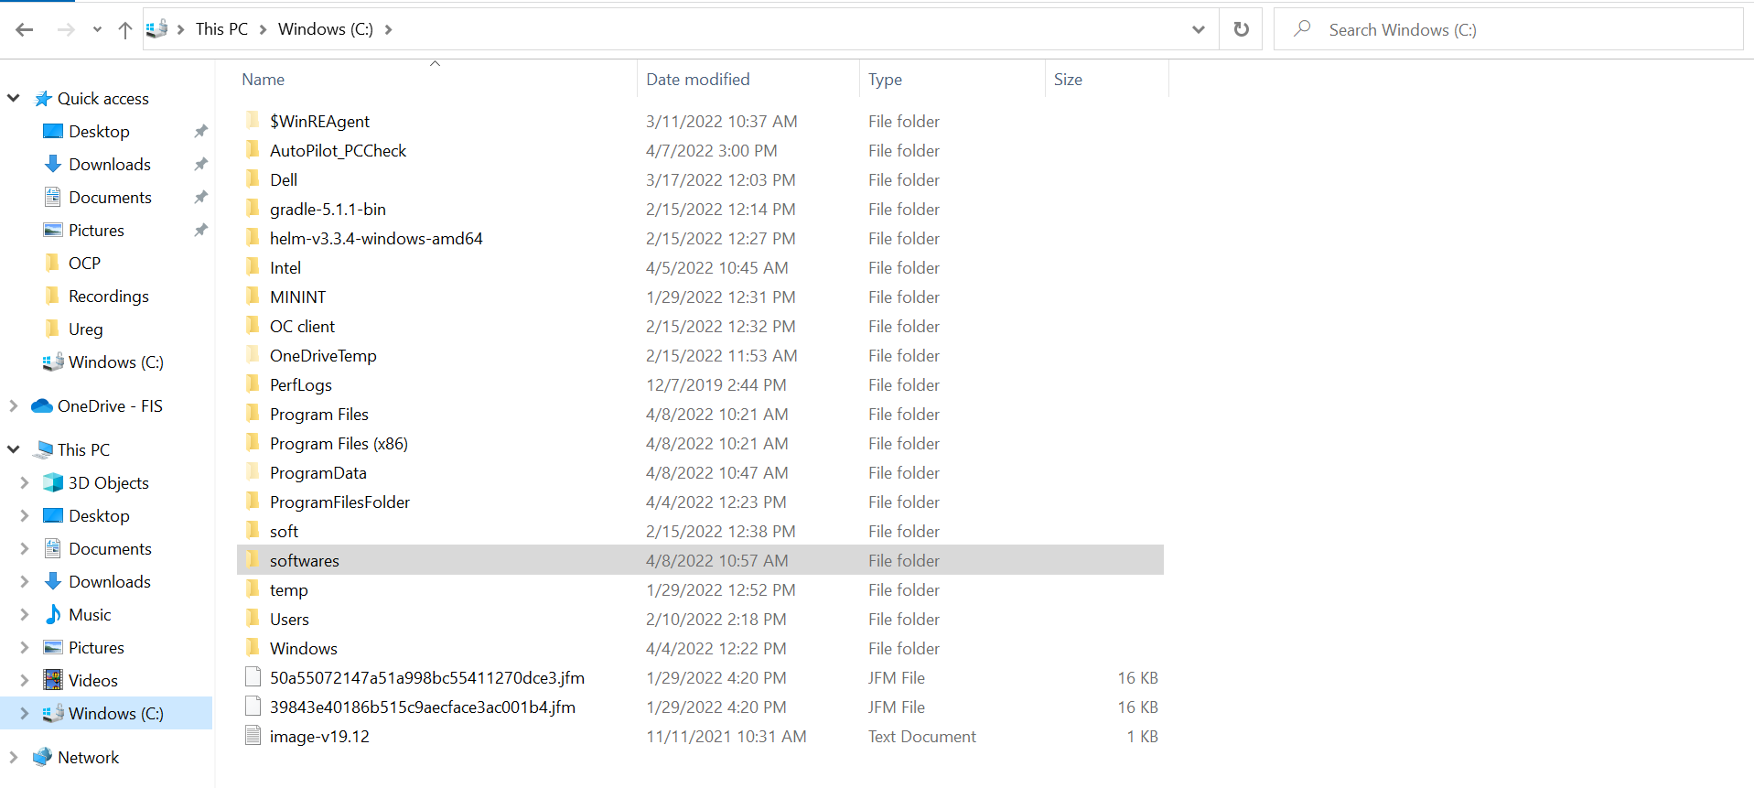
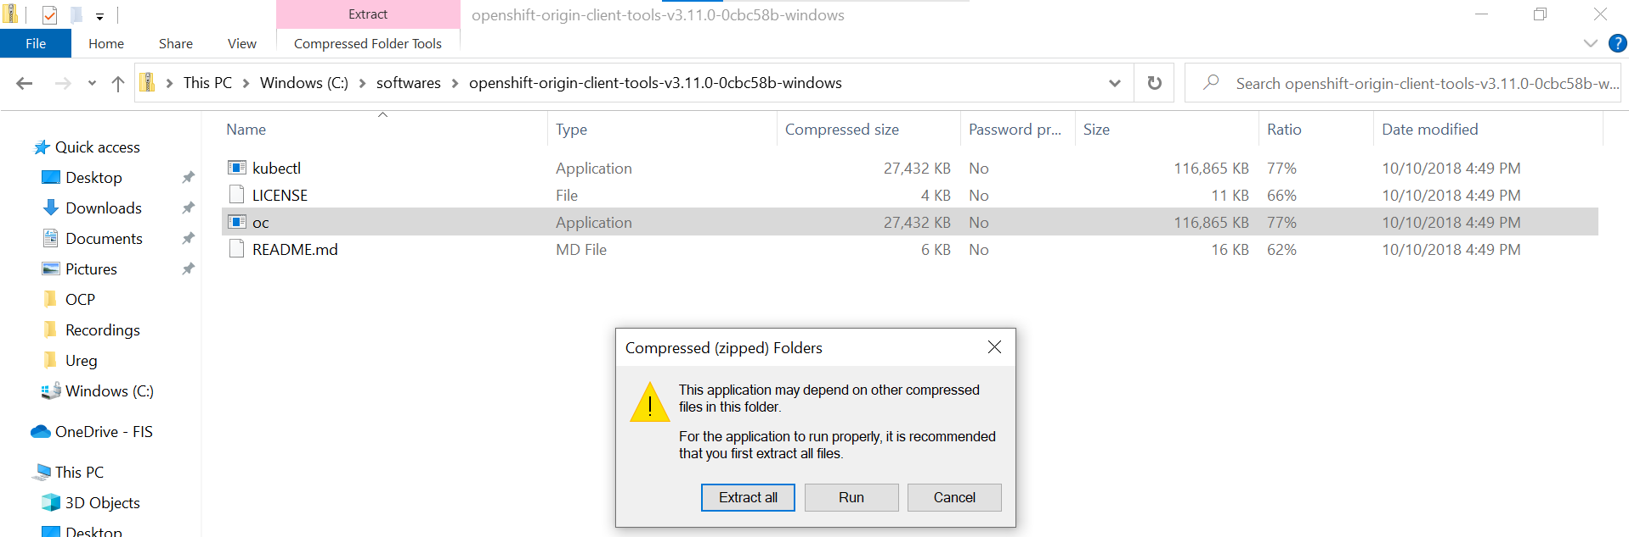

- Go to extracted folder and copy its path.
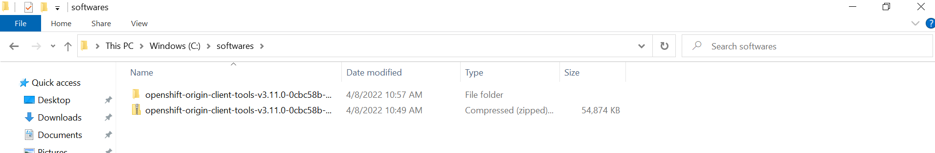
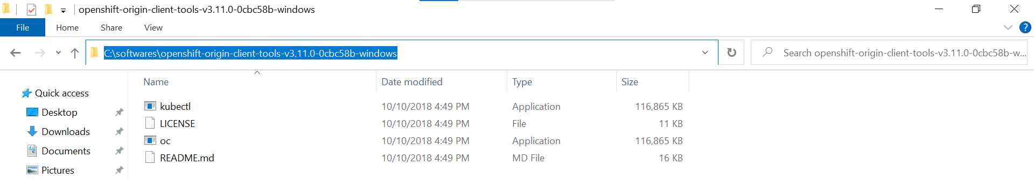

- Add OCP to folder path in PATH environment variable as shown below.
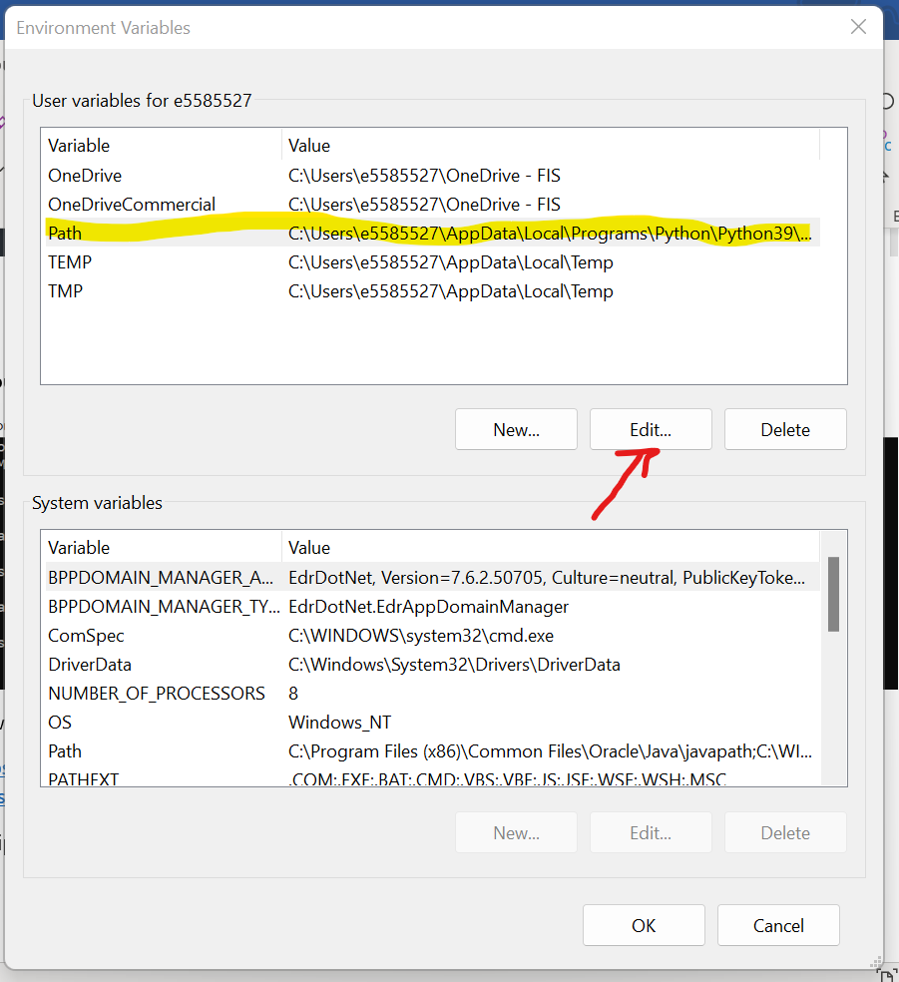
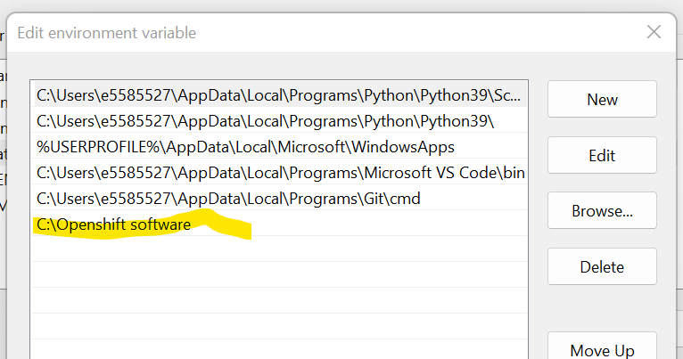

- Now try logging in command prompt using the same command copied from OCP.
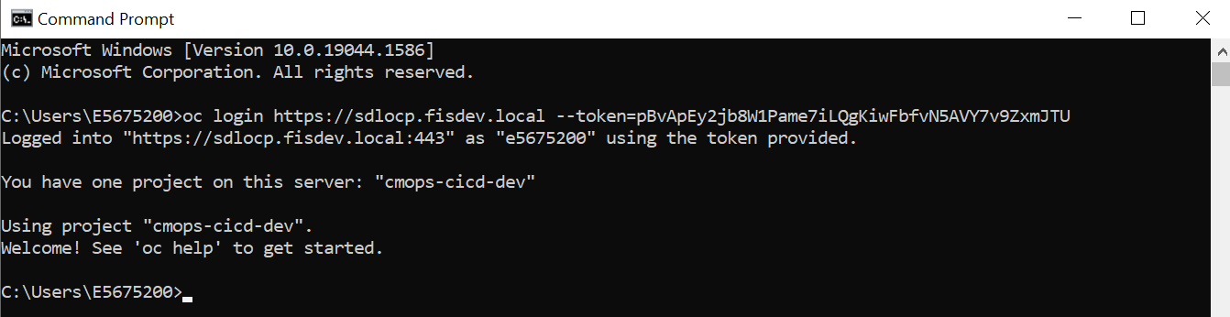
- Enter the project using command - oc project cmops-cicd-dev
- Create a service account using command - oc create sa demopg. Service account name and its password must be procured from the user.
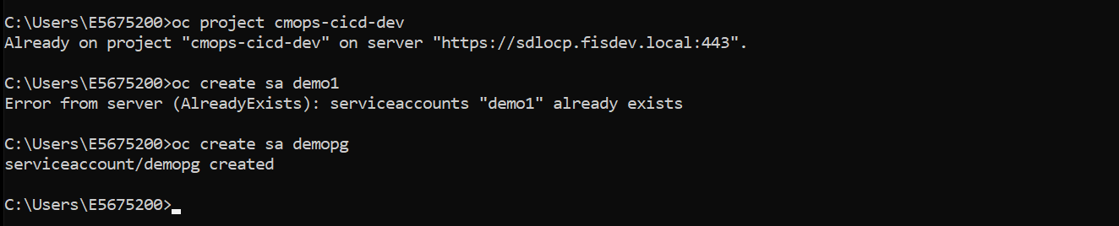
- Come back to OCP UI. Here you can find the service account “demopg” under Resource -> Secrets
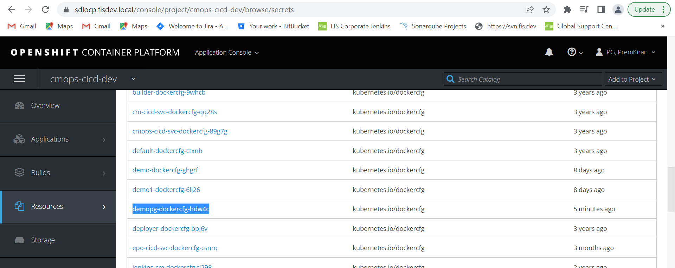
- To edit the membership, go to the following path and provide “edit” access to the service account.
- Resource -> Membership -> Service Accounts -> Edit Membership

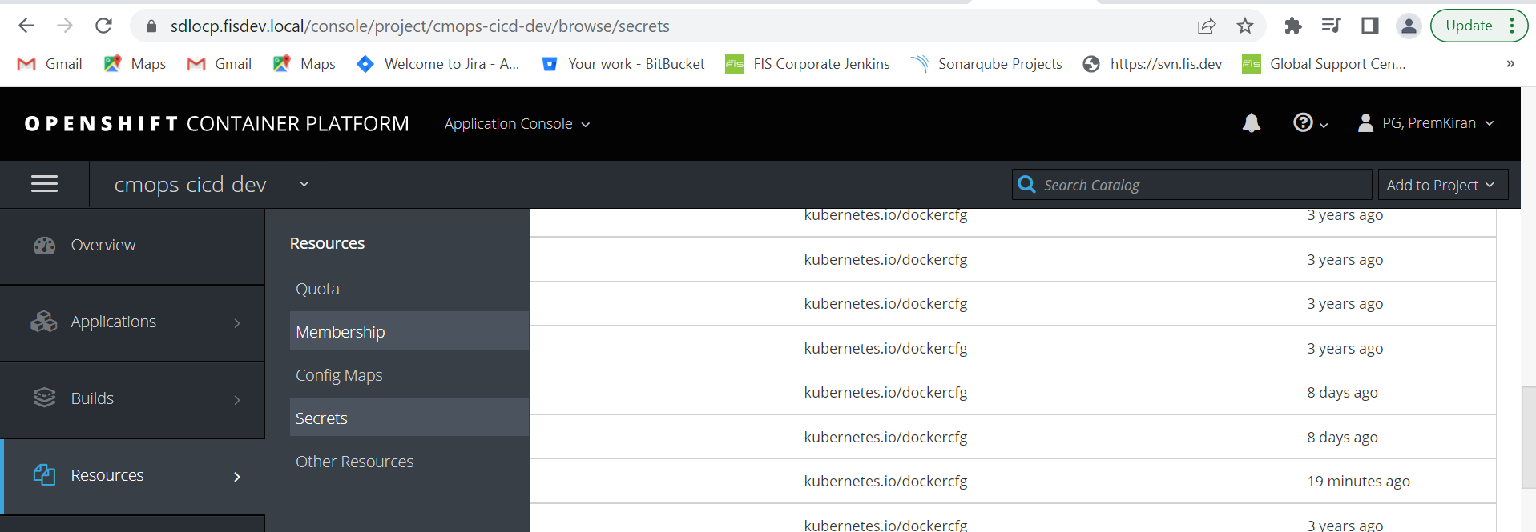

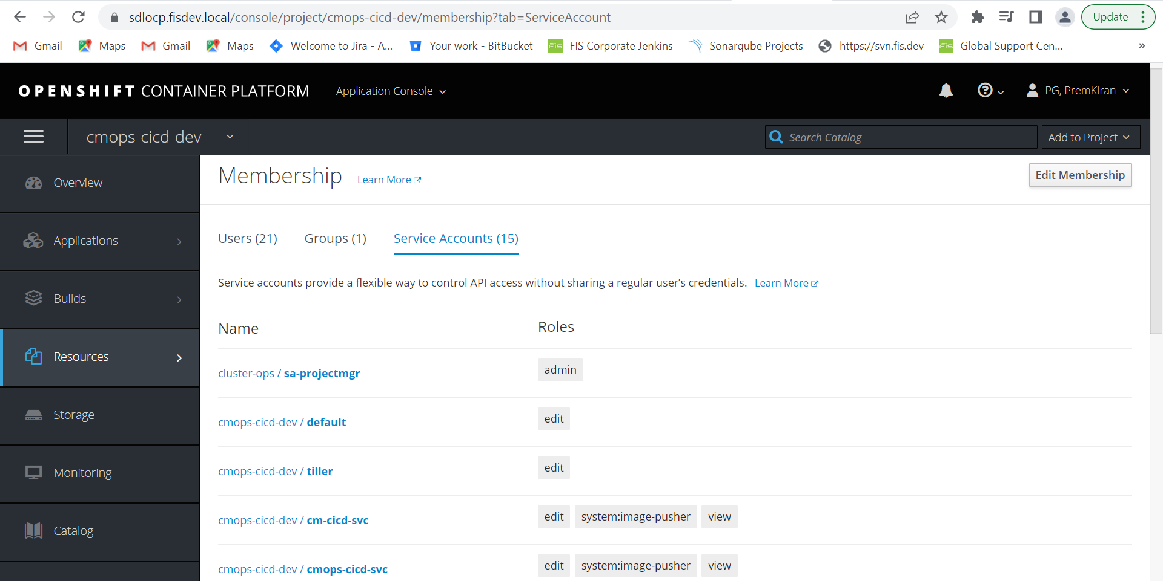

- Select the service account “demopg” that we created earlier

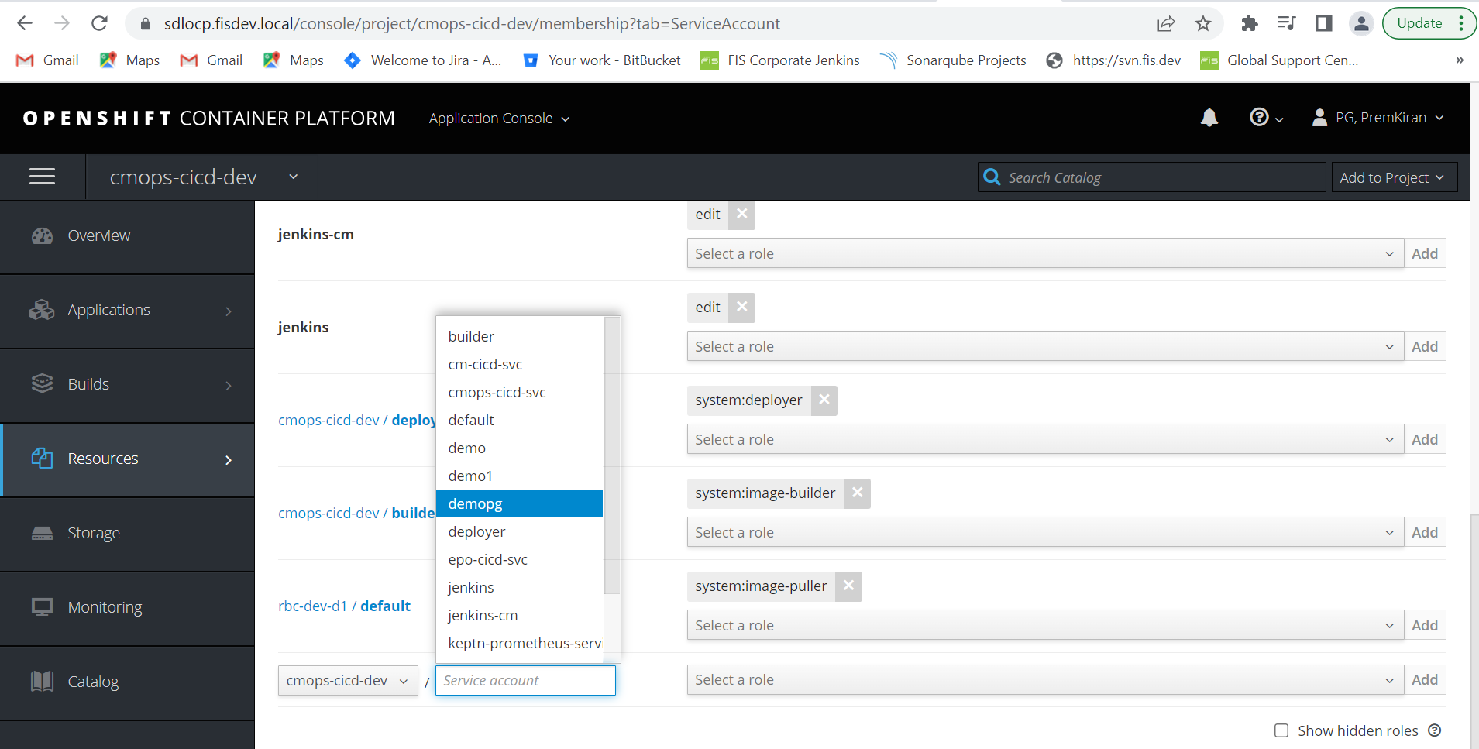

- Give “edit” permission to this service account
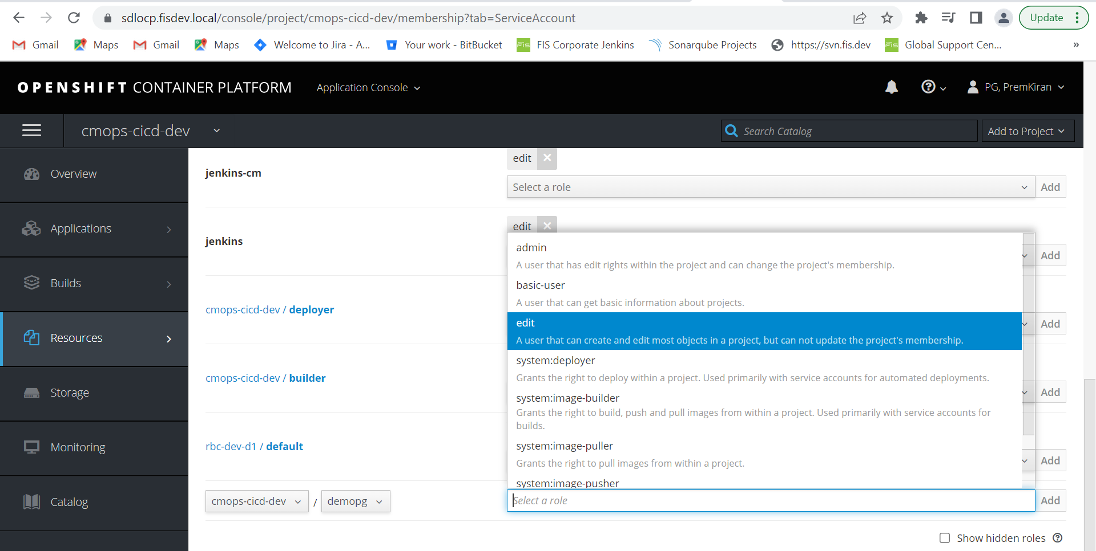

- Once this is done, Go to Resources -> Secret -> Select “demopg token”
Note: There will two tokens select 1st token
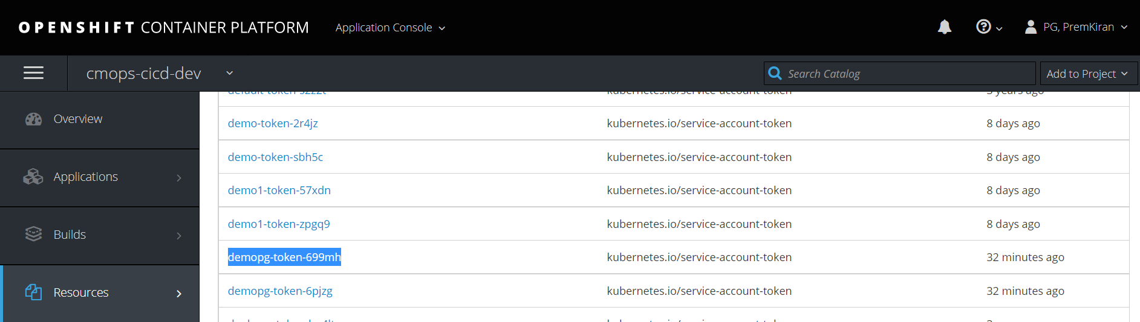
- Click “Reveal Secret”
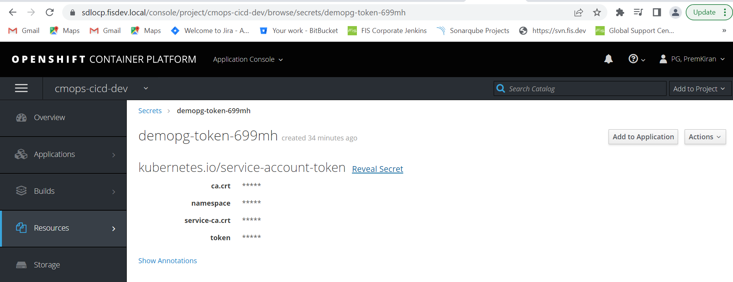

- At the bottom of the page, you need to Copy the token (to ensure there is no error do not manually copy, click on copy to clipboard)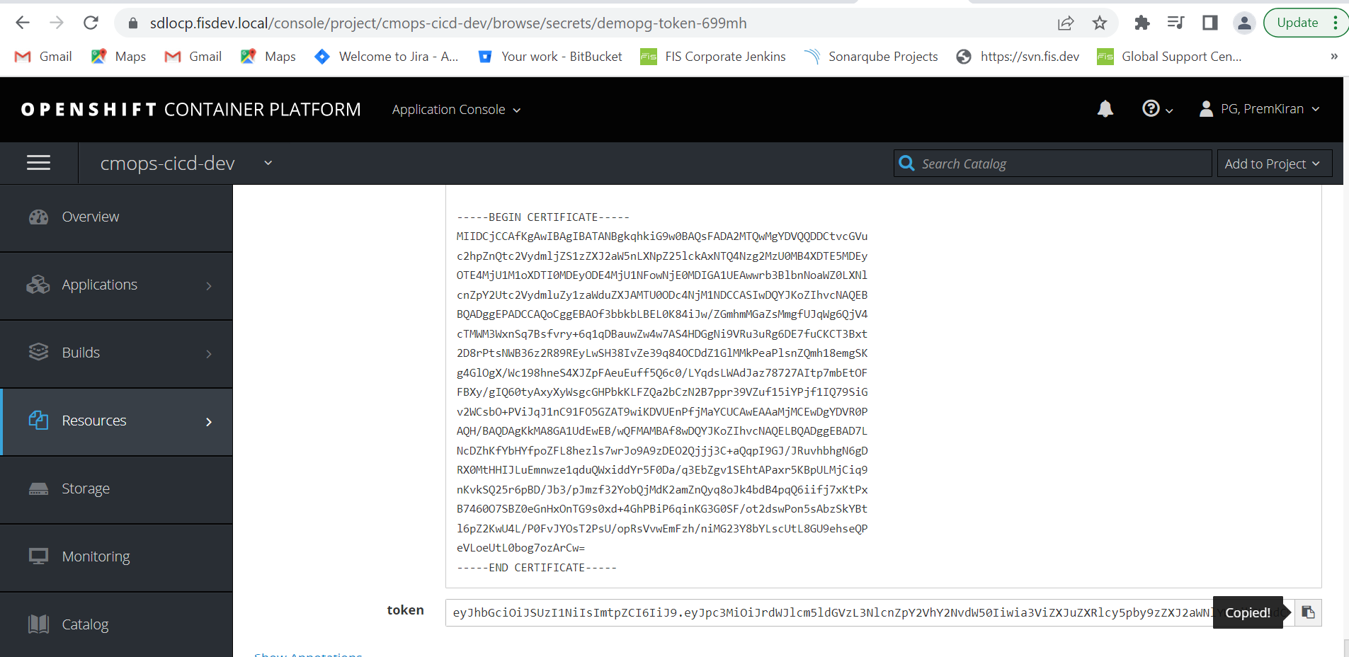

- ADDING CREDENTIALS IN JENKINS
- The copied token should be added in the Jenkins.
- Open the related Jenkins dashboard. On the left side you will find “Manage Jenkins”.
- Scroll down to find “Manage Credentials”.
- Scroll down completely to find “Global”. Add credentials under “Global credentials (unrestricted)”
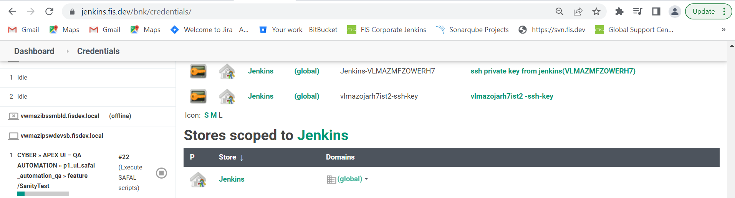

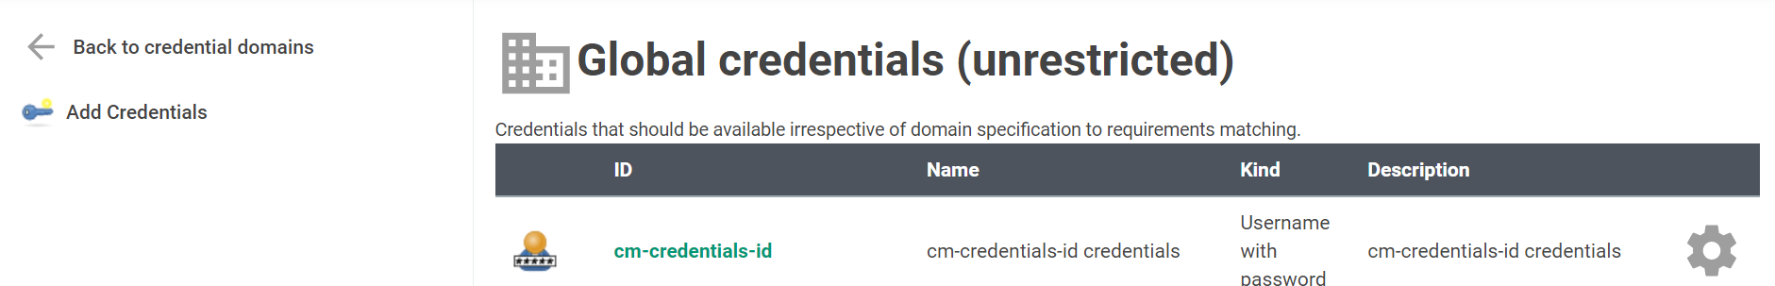
- Kind – Select Secret Text
- Scope – Global (Jenkins, nodes, items, all child items etc)
- Secret – paste the copied secret from OCP.
- ID – naming convention should be - secret account-namespace-cluster
- Secret – Paste the token copied from OCP
- ID: demopg-cmops-cicd-dev-sdlocp
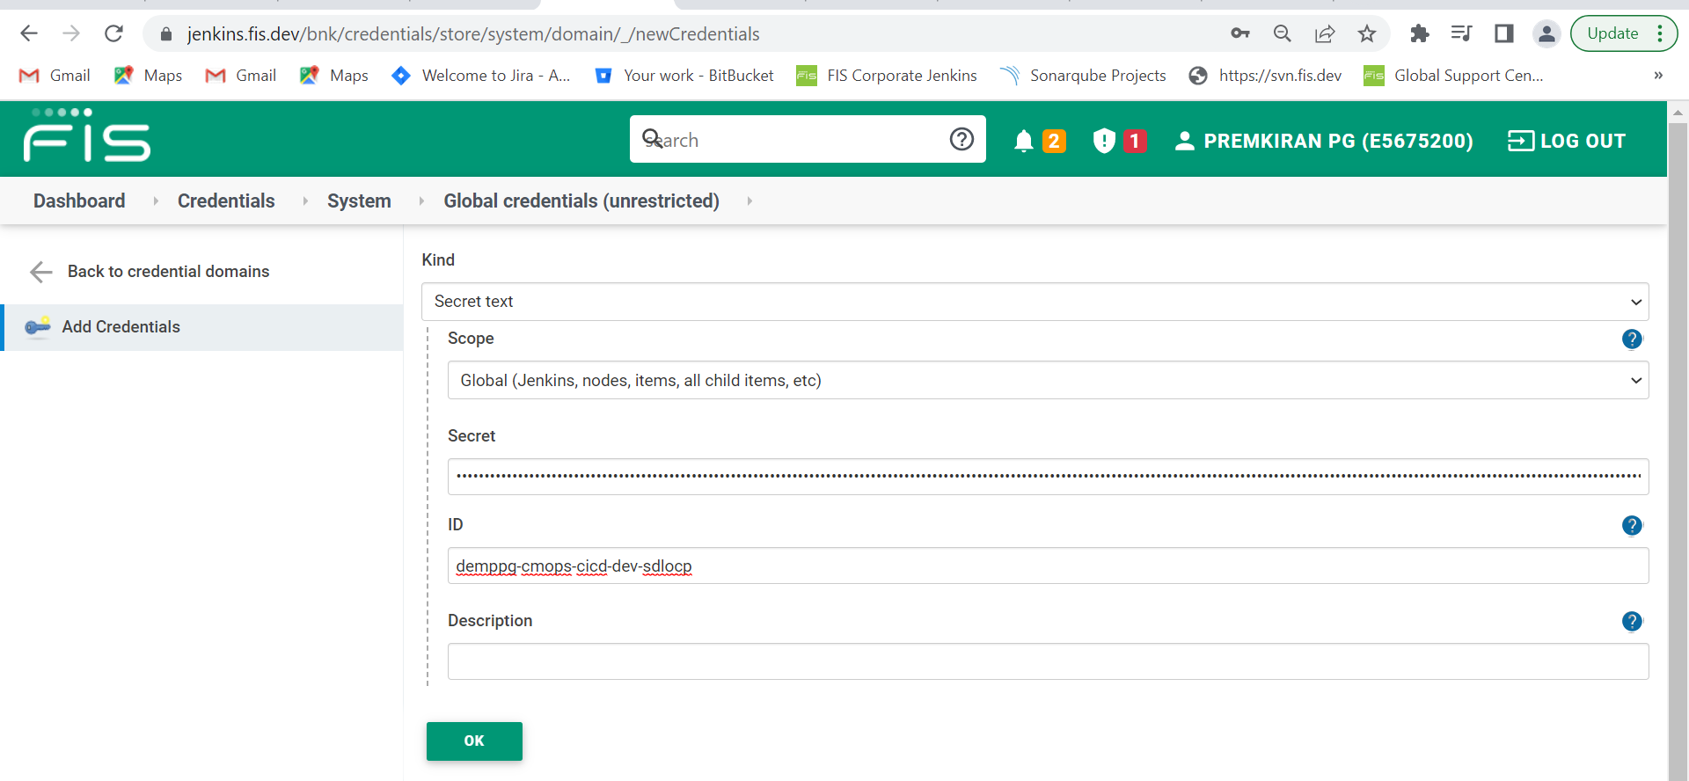

- CONFIGURE CLOUD ON JENKINS:
- Go to the Jenkins URL and click on “Manage Jenkins” on the left side of the page.
- Manage Jenkins -> Manage Nodes and Clouds -> Configure Clouds -> Add new cloud (bottom of the page) -> Select “Kubernetes”
- Rename “Kubernetes” with the OCP namespace. The same should be given for “Kubernetes Namespace” as well.
- Update the credentials with the global credentials created above. Click on “test connection”. If the configurations are fine, the test will be successful.
- Kubernetes URL – OCP URL (only till local needs to be added)
- Ensure to check the “Disable https certificate check” checkbox.
- Jenkins URL should be the one provided by the user.
- Jenkins tunnel should be updated as per the Jenkins instance we are using.
- These can be copied from previous configured node.
- Save the changes. Now Cloud Node is added to “cmops-cicd-dev” namespace.

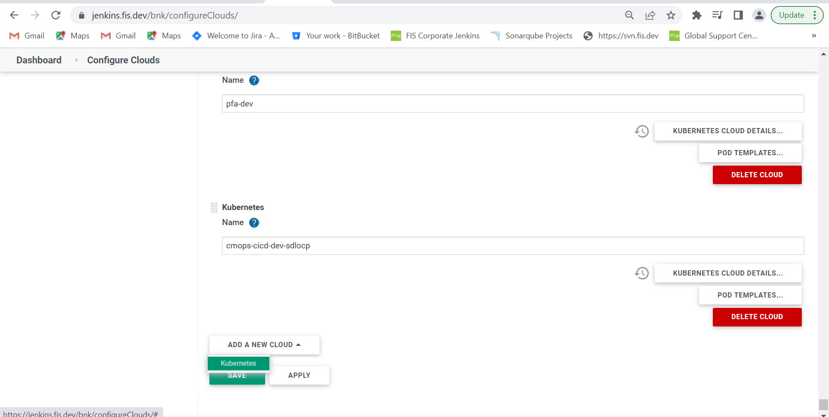
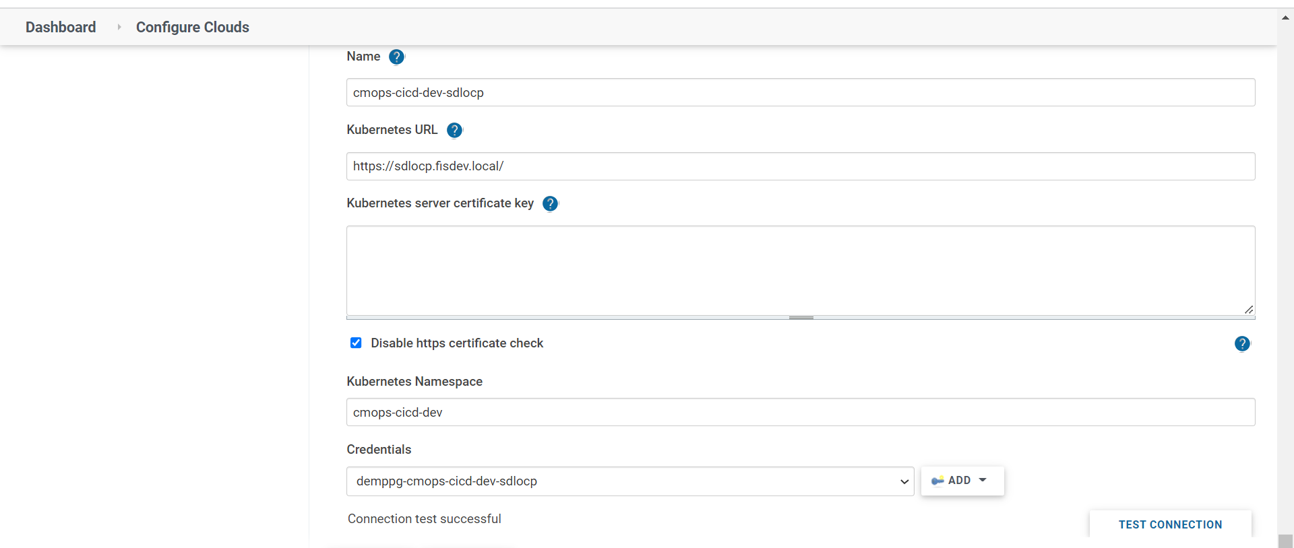
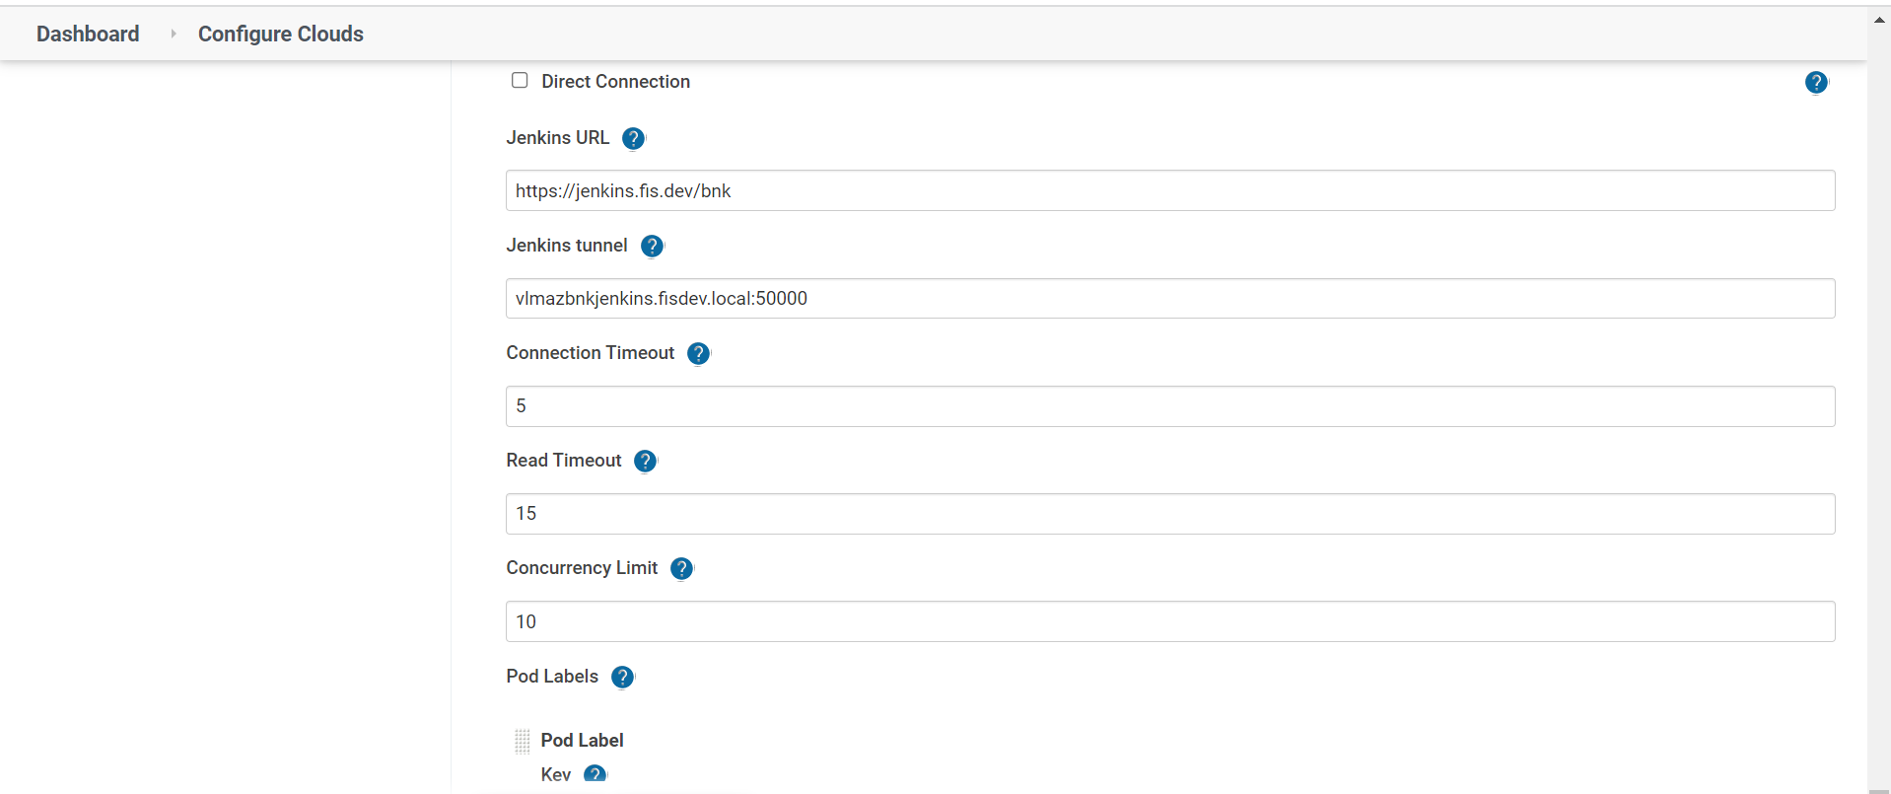

Method 2: (Creating service account in GUI)
Select “Cluster Console”
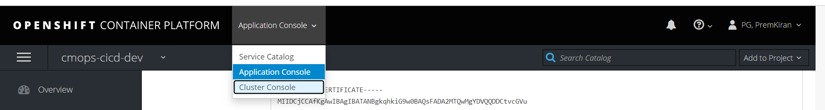

Administration -> Service Account -> Create Service Account -> in the name field give the service account name to be created “demopg1”
Note: Projects: select the namespace “cmops-cicd-dev”
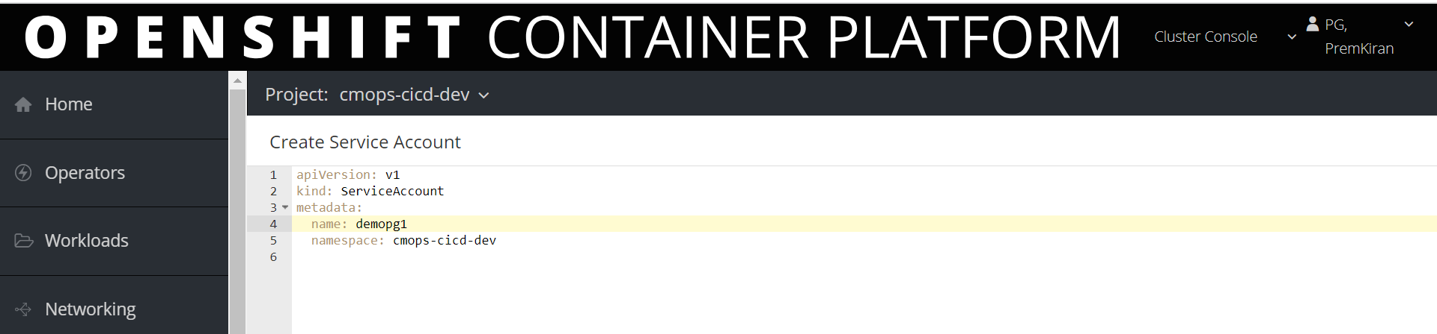
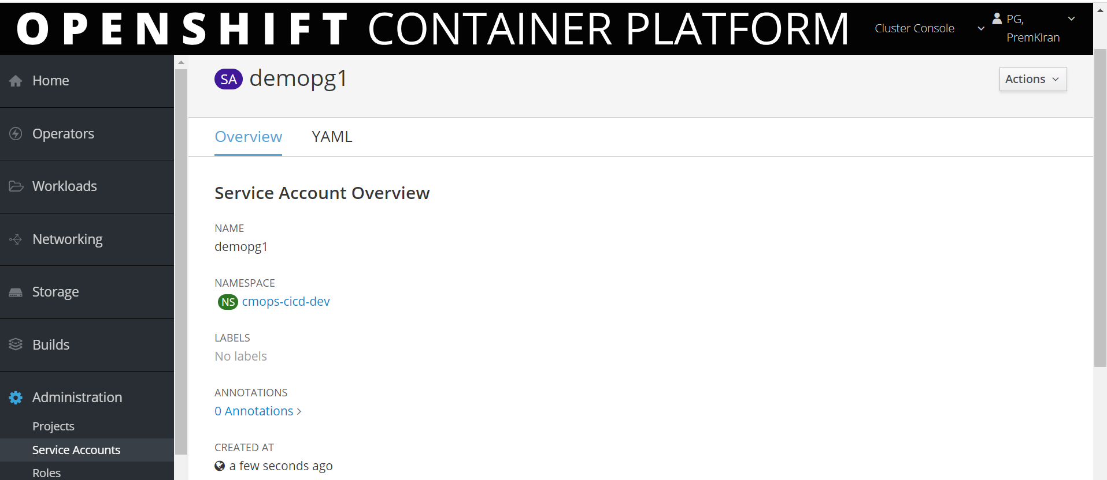
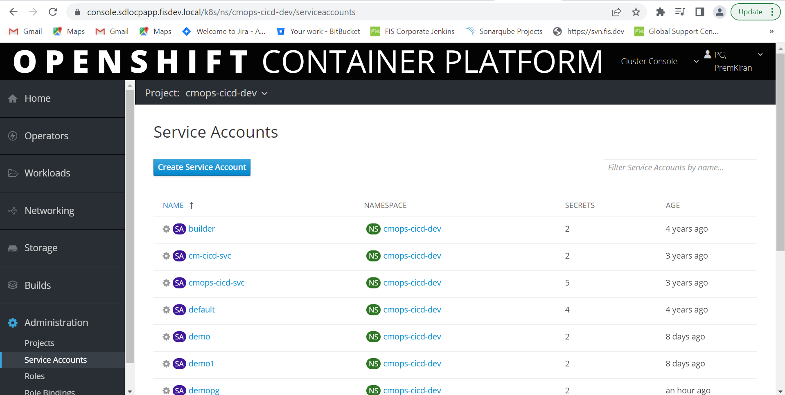
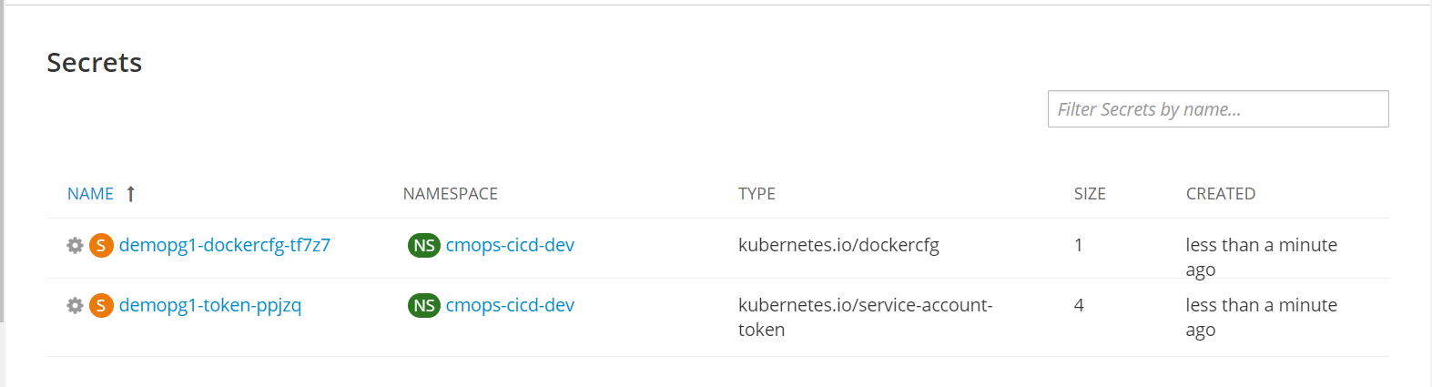
Similar way we can configure the Jenkins cloud node following the above steps

